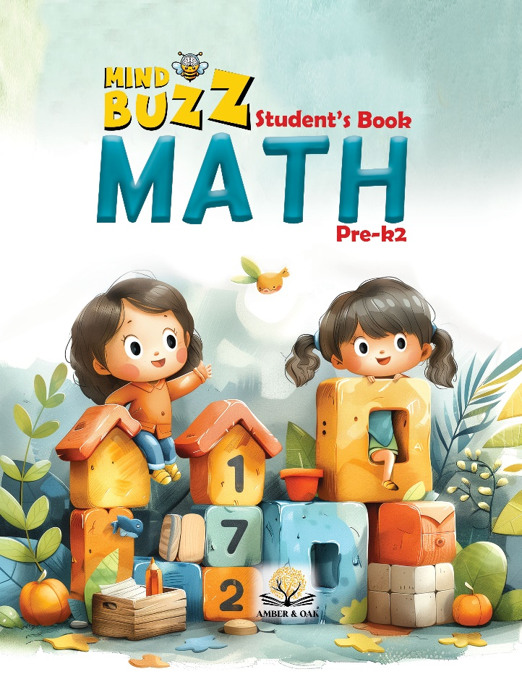

EC2

Lesson Plans

**Review What You Know: Counting and Addition within 10**

**Day 1: Sunday**

**Presentation (5 minutes):**

* **Objective:** Introduce numbers 1 through 10 and basic addition concepts.
* **Activity:**
  + Introduce numbers 1 through 10 using visual aids (e.g., number flashcards).
  + Demonstrate counting from 1 to 10 using fingers.
  + Discuss how numbers can be added together using visual representations (rods, beads).
  + Show how to combine quantities to form sums within 10.

**Materials:**

* Number cards from 1 to 10.
* Red and blue number rods (1 to 10).
* Colored beads representing 1 to 10.
* Sandpaper numbers for (1 to 10).

**Structure:**

* **Introduction (5 minutes):**
  + The teacher presents numbers 1 through 10, explains their significance, and shows how they appear in different forms.
  + Demonstrate simple addition using visual aids (e.g., "2 beads + 3 beads = 5 beads").
* **Workstation Rotations (35 minutes):**
  + **Station 1: Sandpaper Numbers**
    - **Materials:** Sandpaper numbers from 1 to 10.
    - **Student Role:** Trace the sandpaper numbers and name them aloud.
    - **Teacher Role:** Encourage students to feel the texture and correctly pronounce each number.
  + **Station 2: Colored Beads Matching**
    - **Materials:** Colored beads representing 1 to 10, number cards.
    - **Student Role:** Count beads and match them with the correct number card.
    - **Teacher Role:** Assist students in counting and matching quantities accurately.
  + **Station 3: Number Rods Matching**
    - **Materials:** Number rods representing 1 to 10, number cards.
    - **Student Role:** Match rods with the corresponding number cards and verbalize the number.
    - **Teacher Role:** Guide students in correctly identifying and matching rods.
  + **Station 4: Addition with Colored Beads**
    - **Materials:** Colored beads, operation cards (addition within 10).
    - **Student Role:** Use beads to solve simple addition problems and state the sum.
    - **Teacher Role:** Help students understand the concept of adding quantities together.
  + **Station 5: Addition with Number Rods**
    - **Materials:** Red and blue number rods, operation cards (addition within 10).
    - **Student Role:** Use rods to solve addition problems and describe the result.
    - **Teacher Role:** Support students in combining rods to find sums.

**Turn-Taking:**

* Students at each station will take turns within the 7 minutes.
* Teacher ensures smooth transitions and equitable participation.

**Review & Wrap-Up (5 minutes):**

* Brief discussion on the activities completed at each station, emphasizing the concept of adding quantities together.

**Day 2: Monday**

**Presentation (5 minutes):**

* **Objective:** Reinforce counting from 1 to 10 and practice basic addition.
* **Activity:**
  + Review numbers 1 through 10 using visual aids.
  + Demonstrate addition with visual aids (e.g., number rods, beads).
  + Discuss how combining two quantities results in a sum.

**Materials:**

* Number cards for 1 to 10.
* Red and blue number rods (1 to 10).
* Colored beads representing 1 to 10.
* Sandpaper numbers for 1 to 10.

**Structure:**

* **Introduction (5 minutes):**
  + The teacher revisits the numbers 1 through 10 and reinforces counting skills.
  + Introduce more complex addition problems (e.g., "4 beads + 3 beads = 7 beads").
* **Workstation Rotations (35 minutes):**
  + **Station 1: Sandpaper Numbers**
    - **Materials:** Sandpaper numbers from 1 to 10.
    - **Student Role:** Trace and name the numbers as they did on Day 1.
    - **Teacher Role:** Monitor progress and provide support as needed.
  + **Station 2: Colored Beads Matching**
    - **Materials:** Colored beads representing 1 to 10, number cards.
    - **Student Role:** Match beads with the correct number cards and state the number.
    - **Teacher Role:** Ensure accurate counting and matching of beads.
  + **Station 3: Number Rods Matching**
    - **Materials:** Number rods representing 1 to 10, number cards.
    - **Student Role:** Match rods with the corresponding number cards.
    - **Teacher Role:** Reinforce the concept of number recognition and matching.
  + **Station 4: Addition with Colored Beads**
    - **Materials:** Colored beads, operation cards (addition within 10).
    - **Student Role:** Solve addition problems using beads and explain the solution.
    - **Teacher Role:** Support students in understanding how to add quantities together.
  + **Station 5: Addition with Number Rods**
    - **Materials:** Red and blue number rods, operation cards (addition within 10).
    - **Student Role:** Use rods to solve addition problems and describe the total sum.
    - **Teacher Role:** Provide guidance and feedback on students' addition skills.

**Turn-Taking:**

* Students at each station will take turns within the 7 minutes.
* Teacher ensures smooth transitions and equitable participation.

**Review & Wrap-Up (5 minutes):**

* Recap the addition activities and encourage students to share what they learned.

**Day 3: Tuesday**

**Presentation (5 minutes):**

* **Objective:** Focus on matching numbers to quantities and solving addition problems.
* **Activity:**
  + Review numbers 1 through 10.
  + Introduce more complex addition problems and discuss different strategies for solving them.

**Materials:**

* Number cards for 1 to 10.
* Red and blue number rods (1 to 10).
* Colored beads representing 1 to 10.
* Sandpaper numbers for 1 to 10.

**Structure:**

* **Introduction (5 minutes):**
  + The teacher reinforces number recognition and counting from 1 to 10.
  + Discuss how to approach addition problems using different materials (e.g., beads, rods).
* **Workstation Rotations (35 minutes):**
  + **Station 1: Sandpaper Numbers**
    - **Materials:** Sandpaper numbers from 1 to 10.
    - **Student Role:** Trace the numbers and state them aloud, reinforcing recognition.
    - **Teacher Role:** Observe and assist students in correctly tracing and naming numbers.
  + **Station 2: Colored Beads Matching**
    - **Materials:** Colored beads representing 1 to 10, number cards.
    - **Student Role:** Match beads to the corresponding number cards.
    - **Teacher Role:** Guide students in accurate counting and matching.
  + **Station 3: Number Rods Matching**
    - **Materials:** Number rods representing 1 to 10, number cards.
    - **Student Role:** Match rods to number cards and verbalize the number.
    - **Teacher Role:** Ensure students correctly identify and match the rods.
  + **Station 4: Addition with Colored Beads**
    - **Materials:** Colored beads, operation cards (addition within 10).
    - **Student Role:** Use beads to solve more complex addition problems.
    - **Teacher Role:** Support students in breaking down problems and finding the sum.
  + **Station 5: Addition with Number Rods**
    - **Materials:** Red and blue number rods, operation cards (addition within 10).
    - **Student Role:** Use rods to solve addition problems, describe their approach.
    - **Teacher Role:** Provide feedback and encourage students to explain their reasoning.

**Turn-Taking:**

* Students at each station will take turns within the 7 minutes.
* Teacher ensures smooth transitions and equitable participation.

**Review & Wrap-Up (5 minutes):**

* Discuss the different strategies used to solve addition problems and highlight the importance of understanding the process.

**Day 4: Wednesday**

**Presentation (5 minutes):**

* **Objective:** Review counting and addition within 10, introduce problem-solving strategies.
* **Activity:**
  + Briefly review numbers 1 through 10.
  + Focus on different strategies to solve addition problems, such as using manipulatives and visual aids.

**Materials:**

* Number flashcards for 1 to 10.
* Red and blue number rods (1 to 10).
* Colored beads representing 1 to 10.
* Sandpaper numbers for 1 to 10.
* *Mind Buzz Math Book*.

**Structure:**

* **Introduction (5 minutes):**
  + The teacher reviews counting from 1 to 10 and discusses different ways to approach addition problems.
  + Encourage students to think about how they can use materials to solve problems.
* **Workstation Rotations (35 minutes):**
  + **Station 1: Colored Beads Matching**
    - **Materials:** Same as Days 1 to 3.
    - **Student Role:** Count and match beads with the correct number card.
    - **Teacher Role:** Ensure accurate counting and matching.
  + **Station 2: Number Rods Matching**
    - **Materials:** Same as Days 1 to 3.
    - **Student Role:** Match rods with the corresponding number card.
    - **Teacher Role:** Guide students in correctly identifying and matching rods.
  + **Station 3: Addition with Colored Beads**
    - **Materials:** Same as Days 1 to 3.
    - **Student Role:** Solve addition problems using beads and verbalize the sum.
    - **Teacher Role:** Support students in understanding the addition process.
  + **Station 4: Addition with Number Rods**
    - **Materials:** Same as Days 1 to 3.
    - **Student Role:** Use rods to solve addition problems and explain their approach.
    - **Teacher Role:** Encourage problem-solving strategies and provide feedback.
  + **Station 5: Answering Questions in Student Book**
    - **Materials:** *Mind Buzz Math Book*, pencils.
    - **Student Role:** Answer questions about numbers and addition within 10.
    - **Teacher Role:** Review and discuss the answers with the students.

**Turn-Taking:**

* Students at each station will take turns within the 7 minutes.
* Teacher ensures smooth transitions and equitable participation.

**Review & Wrap-Up (5 minutes):**

* Reflect on the problem-solving strategies and the importance of understanding addition concepts.

**Day 5: Thursday**

**Presentation (5 minutes):**

* **Objective:** Summarize the week’s lessons on counting and addition within 10.
* **Activity:**
  + Review the key concepts learned during the week.
  + Engage students in a group activity that reinforces counting and addition.

**Materials:**

* Number flashcards for 1 to 10.
* Red and blue number rods (1 to 10).
* Colored beads representing 1 to 10.
* Sandpaper numbers for 1 to 10.
* *Mind Buzz Math Book*.

**Structure:**

* **Introduction (5 minutes):**
  + The teacher summarizes the week’s lessons on counting and addition.
  + Introduce a group activity where students solve addition problems together.
* **Workstation Rotations (35 minutes):**
  + **Station 1: Colored Beads Matching**
    - **Materials:** Same as previous days.
    - **Student Role:** Count and match beads with the correct number card.
    - **Teacher Role:** Observe and assist students in accurate matching.
  + **Station 2: Number Rods Matching**
    - **Materials:** Same as previous days.
    - **Student Role:** Match rods with the corresponding number card.
    - **Teacher Role:** Guide students in correct identification and matching.
  + **Station 3: Addition with Colored Beads**
    - **Materials:** Same as previous days.
    - **Student Role:** Solve addition problems using beads and describe the sum.
    - **Teacher Role:** Encourage students to articulate their reasoning.
  + **Station 4: Addition with Number Rods**
    - **Materials:** Same as previous days.
    - **Student Role:** Use rods to solve addition problems and explain their thought process.
    - **Teacher Role:** Provide constructive feedback on problem-solving strategies.
  + **Station 5: Answering Questions in Student Book**
    - **Materials:** Same as previous days.
    - **Student Role:** Answer questions about counting and addition within 10.
    - **Teacher Role:** Review the answers and discuss any misconceptions.

**Turn-Taking:**

* Students at each station will take turns within the 7 minutes.
* Teacher ensures smooth transitions and equitable participation.

**Review & Wrap-Up (5 minutes):**

* Conduct a group discussion on the key takeaways from the week.
* Encourage students to share their favorite activity or what they found most challenging.